Removal and Installation:
- Begin by removing the air filter cover and air filter
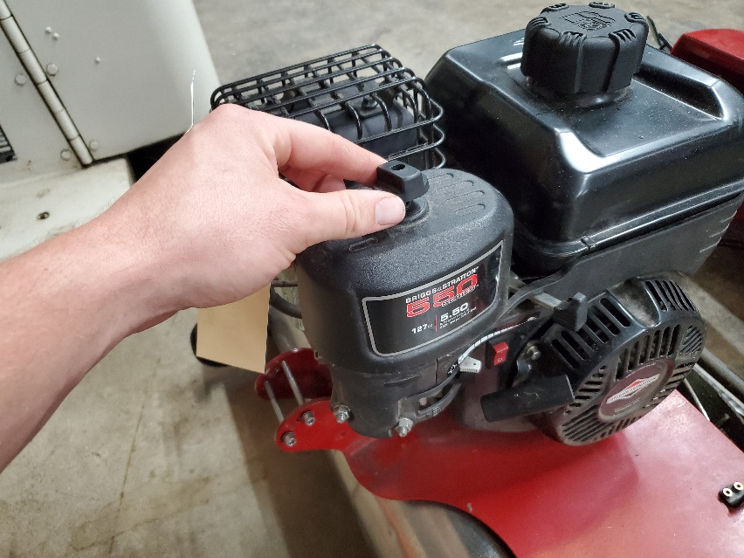
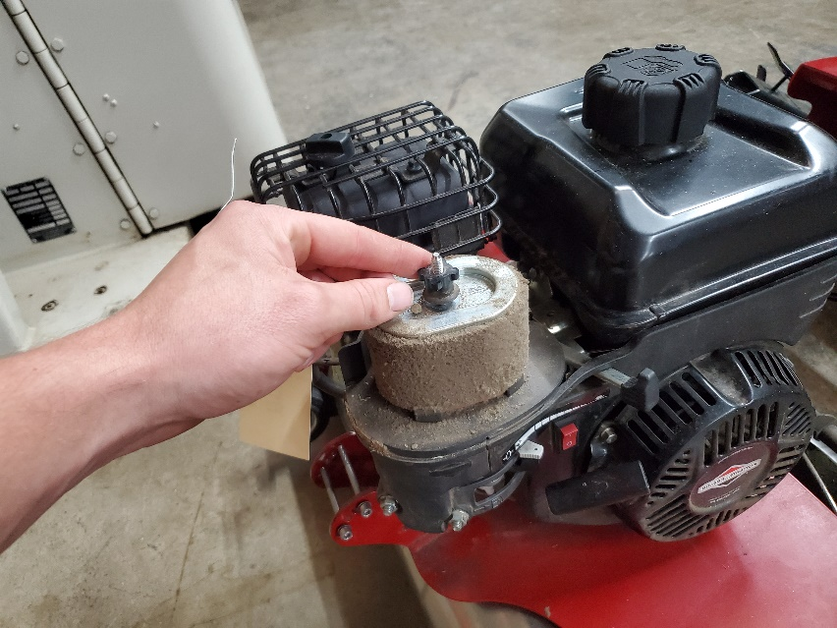
- Loosen the cable holding bracket by backing out the screw.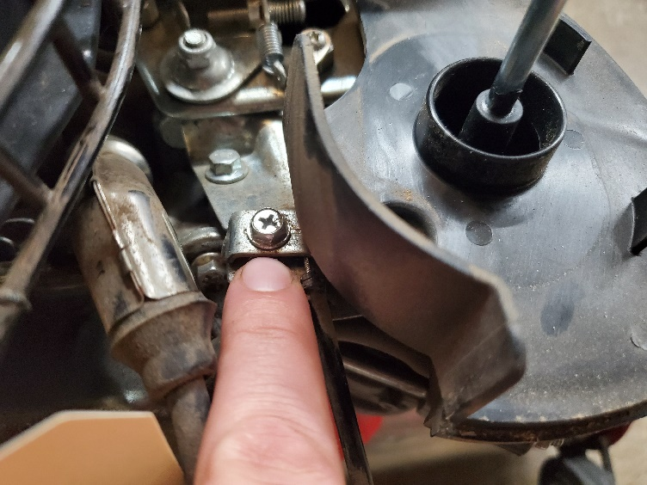
- Remove the screw holding the cable’s eye end. Be sure not to drop the screw.
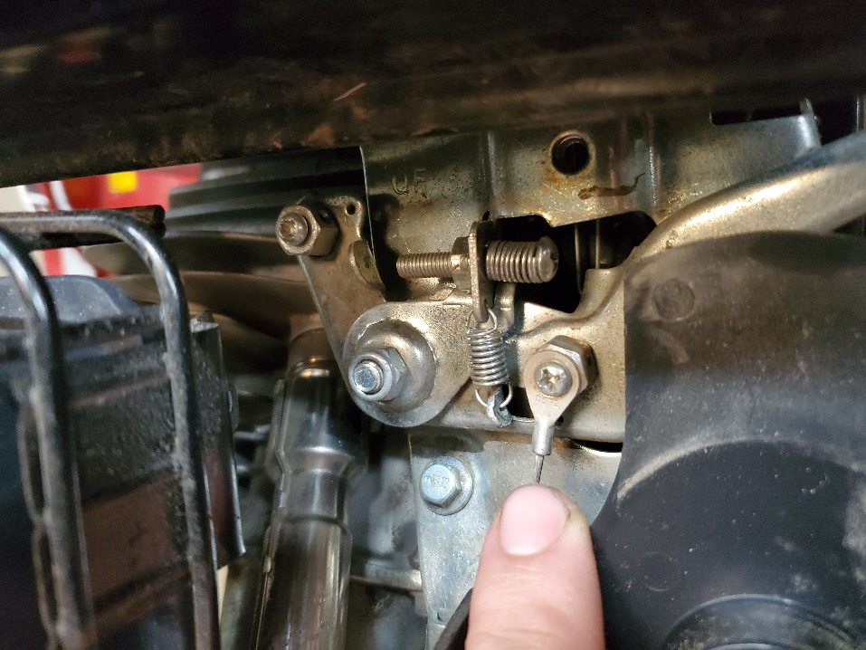

The cable will now slide out underneath the holding bracket.

- Remove the cable from the handlebars by using the 8mm wrench to hold the nut and the 3mm Allen wrench to loosen the bolt. Note: There is a washer between the throttle hole and the cable eye.

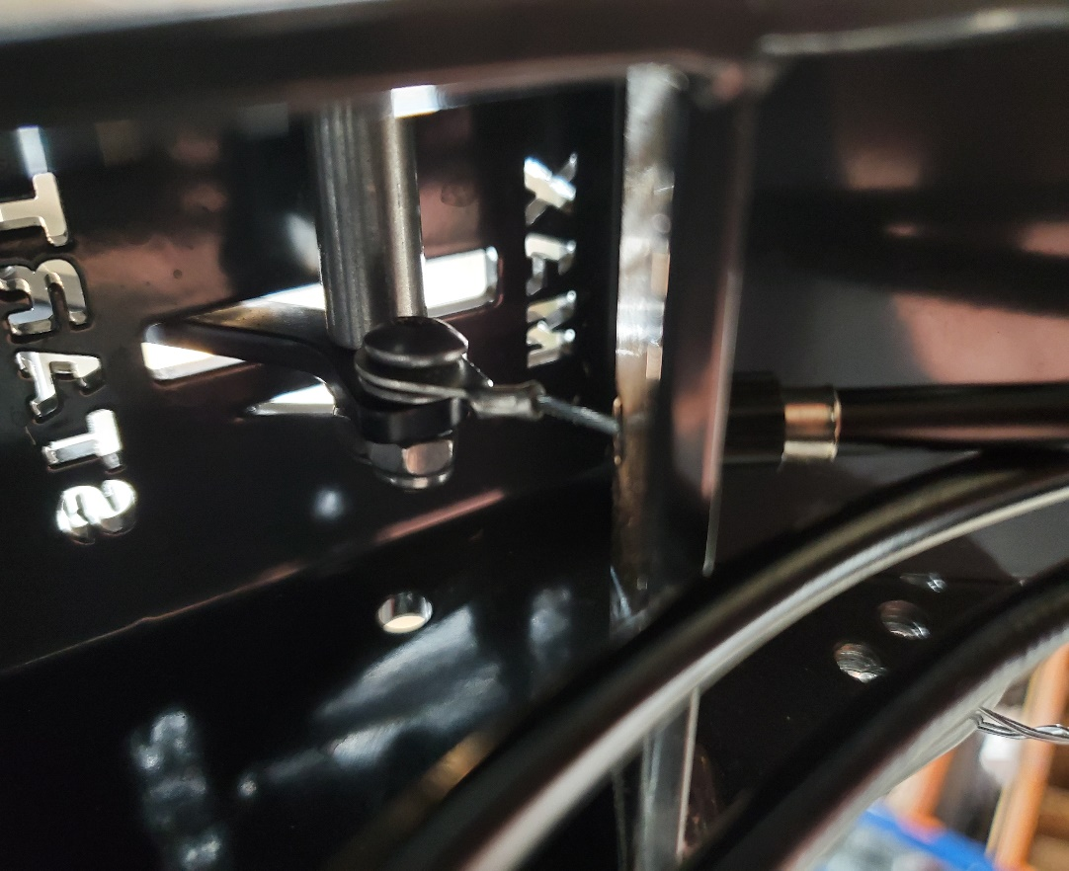

- The throttle cable should now be free. Repeat these instructions in reverse to re-install throttle cable.
*Note*
*When reinstalling cable on grips, do not overtighten nut or bolt. The cable eye needs to be able to swivel on the bolt*
*When reinstalling on engine, place the cable so that the black outer sleeve ends in the middle of the holding bracket*

Adjustments

If adjustments are needed after reinstalling the throttle cable, first be sure that the nut and bolt holding the cable eye at the handlebars is not too tight.

If RPMs do not go high enough, loosen the holding bracket on the engine and pull the cable towards the handlebars so that the black outer sleeve is closer to the handlebars. Re-tighten the holding bracket bolt.

If throttle/RPM “falls” after usage due to vibration, tighten the nut shown in the picture below. Do not overtighten, as this will put undue stress on the throttle cable.