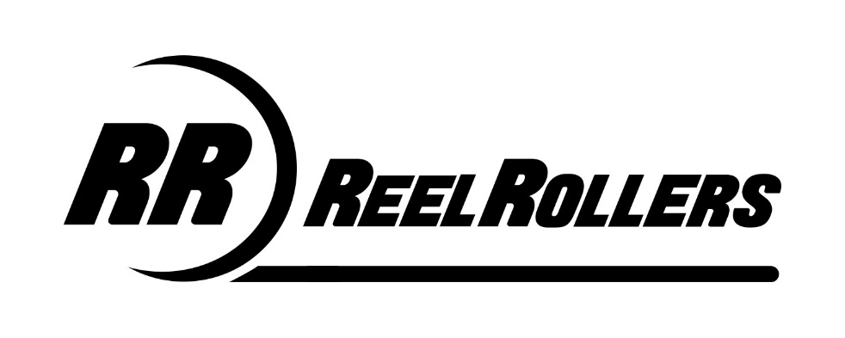
WARRANTY REGISTRATION
Congratulations on the purchase of your new Reel Rollers Revolution lawnmower. This product has been manufactured to high quality stands and guaranteed for domestic use against faulty parts or manufacture for a period of 2 years from the date of purchase. If the machine is used commercially the guarantee period is 90 days from the date of purchase.
If your product fails due to a defect in materials or workmanship during this period it will be repaired or replaced at no charge to yourself provided all repairs are carried out by an authorized service dealer. Delivery and collection of the machines is the owner’s responsibility and not covered under the terms of this guarantee.
This guarantee is subject to the product being serviced at recommended intervals by an authorized service dealer. Please visit www.reelrollers.com to locate your nearest dealer.
This guarantee is not transferable. Proof of the purchase will be required in the event of a claim.
Normal wear and tear and the routine replacement of parts which are subject to normal wear and tear are not covered by the guarantee. Likewise any defect which is the result of misuse, alteration, improper assembly or adjustment, neglect or accident is not covered by this guarantee.
The engine manufacturer guarantees the engine fitted to this machine.
This guarantee is in addition to and does not detract from the contractual right of the owner under statute or common law.

On delivery of your new Reel Rollers Revolution mower, we suggest that you complete the box BELOW.
The information for your machine is on the serial number label, which is fixed on the cutter deck at the base of the handles. You will be asked for these details if you have any problems or require spare parts.
Please keep your receipt, proof of purchase will be required in the event of a claim.

